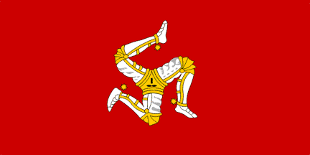Fill this short text in with the missing words:
The Isle of Man is a small island in the middle of _the Irish Sea with a population of about __________people. There are two official languages:___________and ___________. Like Jersey and Guernsey in the Channel Islands, the Isle of Man is a_______________. This means that they are self-governing, and whilst they follow the UK in many respects, they are free to make laws of their own. As the Isle of Man isn’t part of the UK, it is therefore technically not in the______________. The Tynwald – originally a Norse name given to the Island’s parliament - is claimed to be the _______continuous parliament in the world, dating by to 979AD. There is no ______________on the island - and that’s why Top Gear’s Jeremy Clarkson has a property there.
Snaefell - the only true on the Isle of Man - is thought to be the only place in the British Isles from where you can see England, Ireland, Scotland and Wales (and the Isle of Man, obviously).
Manx cats are a breed of cat that originate on the Island - they have a naturally occurring mutation that leaves them without a ____. They can be split into two categories - stumpies; those with a small hint of a tail an inch or so long, and rumpies; the completely tailless.
The Manx Loaghtan is a breed of _______that is only found on the Isle of Man. It is characterized by having four (or sometimes six) horns, and is considered critically endangered, with just breeding females remaining.
Crown Dependency mountain tail oldest European Union sheep
The Irish sea 83,000 English speed limit 1,500 Manx Gaelic
______________________________________________________________________Match the country or state to the correct number.
Which countries or states are not in the Commonwealth?
Facts about English speaking countries... | Country or state
- This is the smallest self-governing place in the world.  - Has the greatest population.  - The fastest man and woman in the world lives there!  - A country in Central America. (Sounds like ‘hasak’)  - The word ‘whiskey’ comes from there.  - There many beautiful lochs in this country.  - Narnia and Lord of the Rings were filmed there.  - It’s the second largest country in the world.  - The 50th US state was actually British.  - A country where everyone speaks with a different accent. | Hawaii New Zealand England Pitcairn India Jamaica Belize Canada Scotland Ireland

